H.T No
Regulations:
A17

Sreenidhi Institute of Science and Technology
(An Autonomous Institution)
Code No: 6D301 Date: 06-Feb-2025 (FN)

B.Tech II-Year I- Semester External Examination, Jan/Feb-2025 (Supplementary)
DISCRETE STRUCTURES AND GRAPH THEORY (ECM)

Time: 3 Hours Max.Marks:75
Note: a) No additional answer sheets will be provided.
b) All sub-parts of a question must be answered at one place only, otherwise it will not be valued.
c) Missing data can be assumed suitably.

Bloom's Cognitive Levels of Learning (BCLL)

Remember | L1 | Apply | L3 | Evaluate | L5
Understand | L2 | Analyze | L4 | Create | L6

Part - A Max.Marks:25

Answer all QUESTIONS.
 |  | BCLL | CO(s) | Marks
1 | Explain converse ,inverse and contra positive of conditional statement 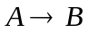 | L2 | CO1 | [2M]
2 | Discuss free and bound variables. | L2 | CO2 | [2M]
3 | Define partial order relation. | L1 | CO3 | [2M]
4 | State generalized principle of inclusion and exclusion. | L1 | CO4 | [2M]
5 | Find the first four terms of sequence 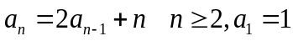 | L1 | CO5 | [2M]
6 | Define Isomorphism of two graphs. | L1 | CO6 | [3M]
7 | Show that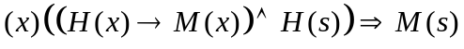. | L1 | CO1 | [3M]
8 | Find coefficient of 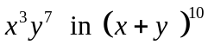 | L1 | CO5 | [3M]
9 | Define an inverse function give an example. | L1 | CO1 | [3M]
10 | Let A be set of natural numbers. Show that the relation  R= {(x, y) / (x-y) is divisible by 3} is an equivalence relation. | L1 | CO3 | [3M]

Part – B Max.Marks:50
ANSWER ANY FIVE QUESTIONS. EACH QUESTION CARRIES 10 MARKS.

 |  |  | BCLL | CO(s) | Marks
11. | a) | Show that 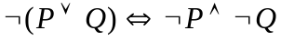 | L1 | CO1 | [5M]
 | b) | Obtain principal conjunctive normal form of (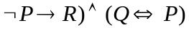 | L2 | CO1 | [5M]
12. | a) | Show that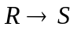 is a valid conclusion from the premises 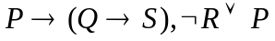 and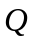 | L1 | CO2 | [5M]
 | b) | Prove that | L3 | CO2 | [5M]
13. | a) | Define equivalence relation and compatibility relation with an example for each. | L1 | CO3 | [5M]
 | b) | Show that f(x, y) = x + y for x, y 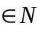 is primitive recursive. | L1 | CO3 | [5M]
14. | a) | Prove the Pascal’s identity C(n, r) = C(n-1, r) + C(n-1, r-1) | L3 | CO4 | [5M]
 | b) | Compute the number of integers between 1 and 1000 that are not divisible by 2, 3, | L5 | CO4 | [5M]
15. | a) | Find the solution of 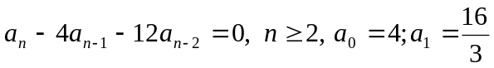 by the method of Characteristic roots. | L1 | CO5 | [5M]
 | b) | Find the number of non-negative integral solutions of  x₁ + x₂ + x₃ + x₄ + x₅ = 30, where, x₁ ≥ 2, x₂ ≥ 3, x₃ ≥ 4, x₄ ≥ 2, x₅ ≥ 0 | L1 | CO5 | [5M]
16. | a) | Define (i) Complete graph (ii) Bipartite graph with suitable examples. | L1 | CO6 | [5M]
 | b) | Prove that in any graph the number of vertices of odd degree is even. | L3 | CO6 | [5M]
17. | a) | Show the following using indirect method of proof. | L1 | CO1 | [5M]
 | b) | Let X be a set and let R and S be relations on X. If both R and S are transitive, then show that the relation 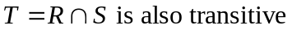. | L1 | CO2 | [5M]
18. | a) | Find the coefficient of | L1 | CO4 | [5M]
 | b) | Solve using generating functions the recurrence relation. | L2 | CO5 | [5M]

-- 00 -- 00 –

